**8. ReactJS-HOL**

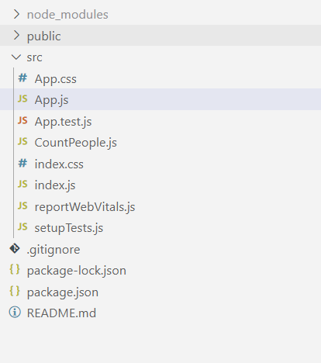

**CountPeople.js**

import React, { Component } from 'react';

class CountPeople extends Component {

  constructor(props) {

    super(props);

    this.state = {

      entryCount: 0,

      exitCount: 0

    };

  }

  updateEntry = () => {

    this.setState(prevState => ({

      entryCount: prevState.entryCount + 1

    }));

  };

  updateExit = () => {

    this.setState(prevState => ({

      exitCount: prevState.exitCount + 1

    }));

  };

  render() {

    return (

      <div style={{ textAlign: 'center', padding: '30px' }}>

        <h1>🚶‍♂️ Mall People Counter</h1>

        <p><strong>People Entered:</strong> {this.state.entryCount}</p>

        <p><strong>People Exited:</strong> {this.state.exitCount}</p>

        <button onClick={this.updateEntry} style={{ marginRight: '10px' }}>

          Login

        </button>

        <button onClick={this.updateExit}>

          Exit

        </button>

      </div>

    );

  }

}

export default CountPeople;

**App.js**

import React from 'react';

import CountPeople from './CountPeople';

function App() {

return (

<div className="App">

<CountPeople />

</div>

);

}

export default App;

**OUTPUT**

